2020

Amol Kakade

Personal use only (Revisions)

12/14/2020

Revision: C Language

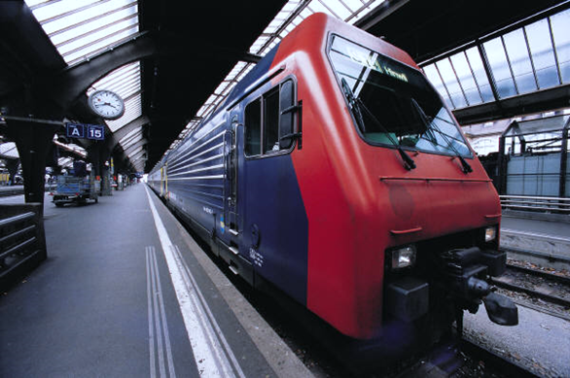

Table of Contents

1. Basic Introduction to C Language 2

1.1 Characteristics of C Language 2

1.2 Applications of C Language 2

2. Character Set 3

# Basic Introduction to C Language

‘C’ language was developed at ‘Bell Telephony labs, USA’ (now AT & T) in 1972. It was outcome of the efforts of Mr. Dennis Ritchie and Mr. Brian Kernighan. It was derived from two early programming languages BCPL (Basic Combined Programming Language) and B language.

BCPL was developed by Mr. Martin Richards. B was developed by Mr. Ken Thompson. In 1970 Mr. Ken Thompson wrote a new language document for UNIX operating system on a PDP-7 machine and took a first character of BCPL for naming is programming language.

in 1972, Dennis Ritchie developed a new version of B and named it as C. Initially there was a plan to develop a UNIX operating system using C language but C language itself is implemented on UNIX operating system. In 1978 Dennis Ritchie and Brian Kernighan jointly published a detailed description of C language document. It is known as ‘K & R C’. C was exclusively used in Bell Laboratories before it was released to commercial applications in 1978.

## Characteristics of C Language

Below are characteristics of C language –

1. C is general purpose programming language.
2. C is structured programming language

Etc.

## Applications of C Language

Below are general domains where C is used for developments.

1. System software

* Operating Systems
* Interpreters
* Compilers
* Assemblers
* Linkers
* Loaders
* Editors

1. Application software

* DBMS
* Graphics Packages
* Spread Sheets
* CAD CAM applications
* Word Processors
* Engineering Applications

# Character Set

Every programming language have its own set of characters to form the lexical elements. Character set used in C language are grouped in below three categories

1. Alphabets
2. Digits
3. Special characters

|  |  |  |
| --- | --- | --- |
| Alphabets | Upper case letters | A-Z |
| Lower case letters | a-z |
| Digits | All digits | 0 to 9 |
| Special Characters | , Comma | + Plus sign |
| . Period | - Minus sign |
| : Colon | * asterisk |
| ; Semicolon | / Slash |
| ‘ Apostrophe | \ Backslash |
| “ Quotation mark | % percentage sign |
| ? Question mark | & Ampersand |
| ! Exclamation mark | ^ Caret |
| _ Underscore | ~ Tilde |
| # Hash | < Less Than |
| = Equal sign | > Greater Than |
| | Pipeline character |  |
| ( Left Parenthesis | ) Right Parenthesis |
| [ Left Bracket | ] Right Bracket |
| { Left Brace | } Right Brace |